Organelles and inter-organellar communication.

Health and safety:

Risk: Fixative contains formaldehyde. Formaldehyde is toxic by contact and inhalation.
Control: Always use gloves while handling the tubes containing fixative. Do the application and removal of fixative, and its incubation, in the designated fume cupboards. Rinse any potential spill with plenty of water.
Risk: Ethanol is flamable and has a low flash point.
Control: Use caution when destaining with hot ethanol. Pipette it gently. Keep away from any possible open flame.
Risk: Sharps.
Control: Beware that scalpels are extremely sharp, do not make any fast movements while holding them. Ask your supervisor for help changing the blade if necessary. Microscope cover slips can also easily brake into fine sharps.
Risk: Irritant chemicals.
Control: Although 5-bromo-4-chloro-3-indolyl glucuronide (X-gluc), EDTA and TRIS are barely toxic at the concentrations used, use caution when working with any laboratory solutions.
Risk: Hot water.
Control: Gloves and lab coat. Use caution when placing and removing tubes from the hot water bath.

Aims
By the end you should have:
- reflected on the dynamics of organelles inside cells, and how cells are built from a number of semiautonomous, interacting components.
- explored the evolutionary origin of some organelles
- become familiar with the use of reporter gene technology.
- gained some experience of the use of genome databases

Introduction

Organelle division: organelles depend on genes in the nucleus
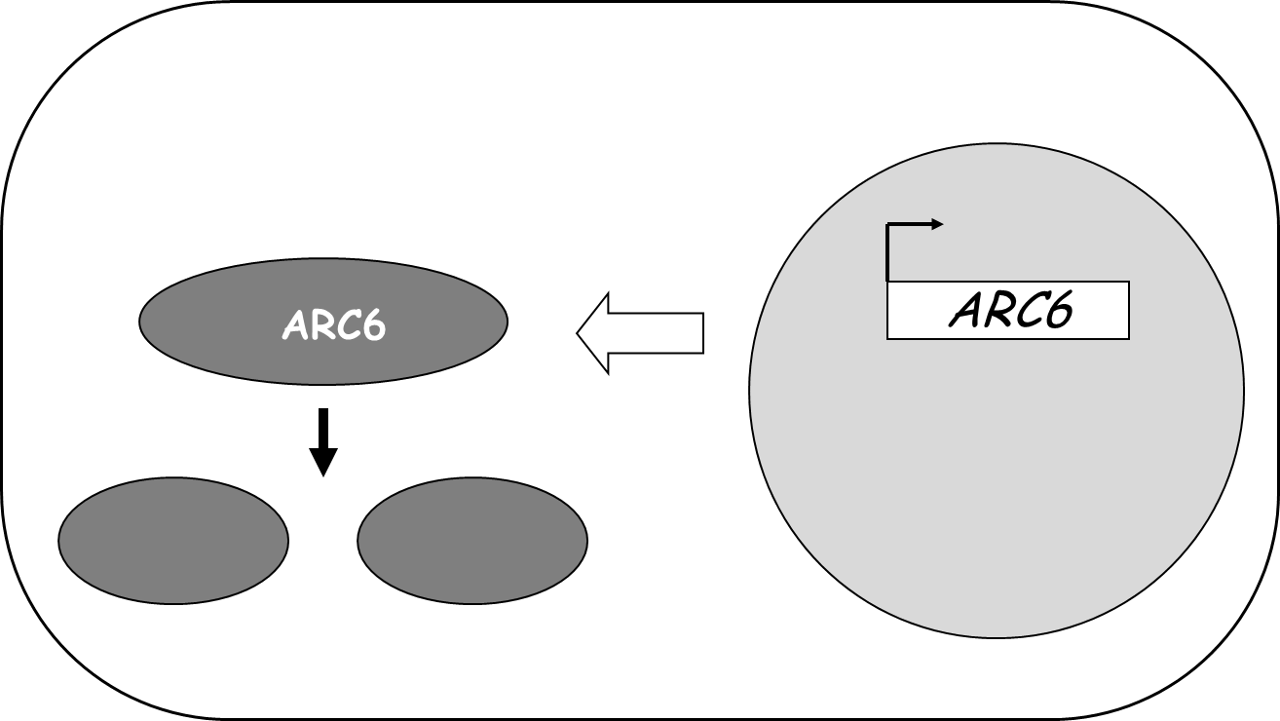
Cells contain a number of different organelles. Some of them are part of the endomembrane system, but some have a semiautonomous nature. This is a result of their origin as prokaryotes which became ‘endosymbionts’. Mitochondria, once alpha-proteobacteria, are almost universally present in eukaryotes, while plant cells contain in addition to mitochondria, plastids, known to descend from cyanobacteria. Since plastids only derive from other plastids, mechanisms have to be in place to ensure that these organelles divide, and that upon mitosis every daughter cell inherits some of them. Both mitochondrial and plastidial division have similarities to bacterial fission, but particularly for plastids (relatively larger), proteins of cyanobacterial origin have been retained for these processes to take place. Most of the ancestral organellar (prokaryotic) genes, including these division genes, have gradually migrated to the eukaryotic host’s nucleus. As a result, nuclear mutations allow the identification of genes which are involved in organelle division. Such mutations show ‘normal’, mendelian inheritance, as opposed to organelle genome mutations which would show maternal inheritance. In this practical you will examine the arc6 (accumulation and replication of chloroplasts 6) mutant of Arabidopsis, defective in the ARC6 gene. The ARC6 protein is one of a number necessary for the assembly of the plastid division apparatus, therefore the arc6 mutant will display a defective plastid division phenotype.

The flip side: genes in the nucleus depend on organelle signals (i.e. on intracellular communication)
One key consequence of the migration of genes from the ancestral bacterial endosymbiont to the host’s nucleus is that the newly moved genes are expressed in the nucleo/cytoplasm (contained and transcribed in the nucleus and translated in the cytoplasm), while their proteins, after import, will be functional in the organellar compartment, in mitochondria or plastids. While cells can, temporarily or imperfectly, live with malfunctioning organelles, the protein products destined for those organelles would in those circumstances be wasted and could, in some cases, actually be harmful outside their target compartment. As a result, pathways of organelle-to-nucleus communication during organelle biogenesis have evolved, which allow the nucleus to respond to the physiological status on the organelles. In plants, for example, nuclear genes for proteins related to photosynthesis are expressed only if the cell contains viable chloroplasts or proplastids into which to import the products of those genes. This reveals the existence of signals produced by the plastids and which can switch on or off the expression of nuclear photosynthetic genes, a fascinating kind of intracellular conversation. This phenomenon of plastid-to-nucleus communication will also be observed in this practical. To observe this we will examine plants grown in vitro, either healthy or treated with an antibiotic, lincomycin. Lincomycin is an inhibitor of translation in prokaryotic-type 70S ribosomes. 70S is a measure of “sedimentation” under centrifugation and, indirectly, size. The cytoplasm of all eukaryotes contains 80S ribosomes, but mitochondria and plastids possess 70S-type ribosomes, and those of plastids are still sensitive to lincomycin (they have not diverged much): In plants treated with lincomycin, protein synthesis in plastids, of the few plastid-encoded genes, is severely reduced, leading to dysfunctional chloroplasts (which turn white), while cytoplasmic translation in 80S ribosomes (of mRNA derived from nuclear genes) is not affected. Lyncomycin has no effect on 80S ribosomes, or even on mitochondrial 70S ones: this makes it useful as an antibiotic: a poison specific to bacteria. Lyncomycin will allow us to disable chloroplasts, and examine whether this affects the expression of nuclear genes.

Reporter gene technology
One way of examining gene expression is through the use of reporter genes. These are genes encoding robust proteins, often enzymes, whose activity is easy to assay, but is absent in organisms not harbouring the reporter. One of the most popular reporter genes in plants is the UidA gene, encoding a hydrolitic enzyme, β-glucuronidase, or GUS. Because of this the gene is also often called the GUS gene. It originates from bacteria, and its activity is absent from plants naturally, it will only be present if an investigator has actually introduced the UidA gene into the nucleus of cells of that plant. The enzyme catalyses the following reaction:
GUS
X-O-glucuronide
X (coloured) + Glucuronic acid

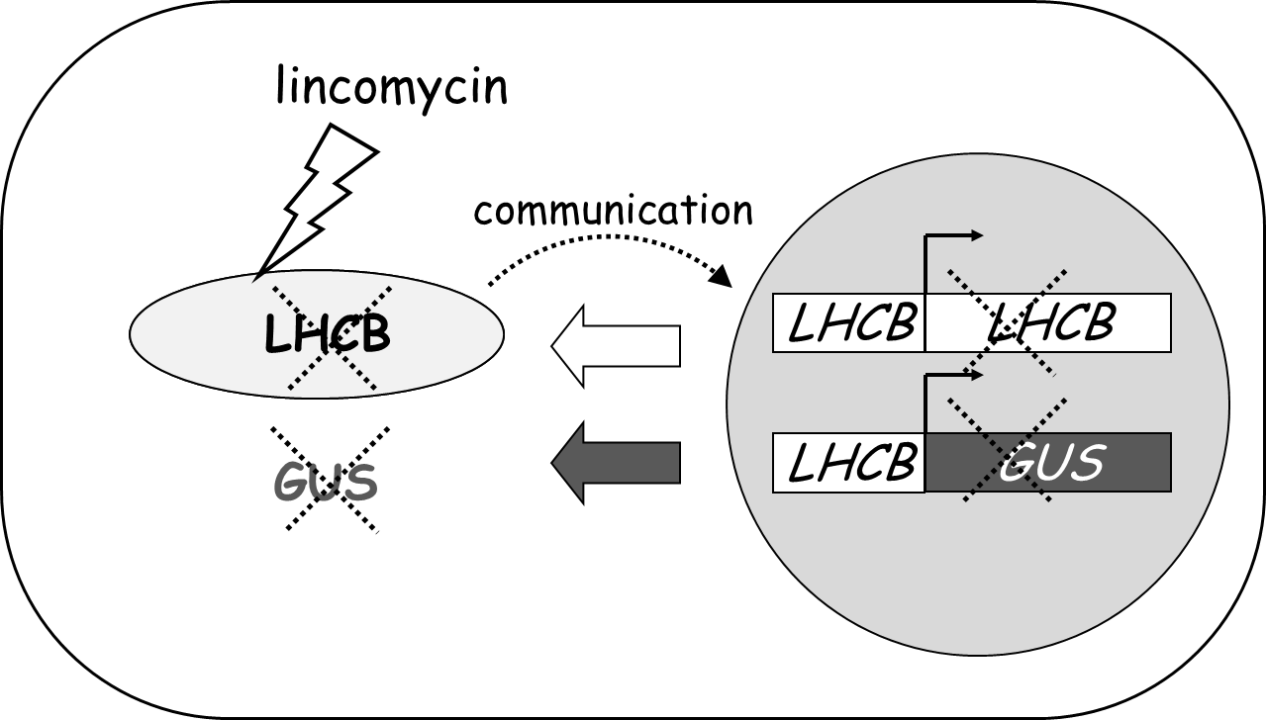
If X, but not the X-O-glucuronide, is a coloured substance, then incubation of a tissue in the presence of the colourless substrate (X-O-glucuronide) will result in the appearance of the X colour wherever there is GUS activity. The molecular ‘trick’ consists of placing the UidA gene in the nucleus under the control of the promoter of an endogenous plant gene. Once this is done, the appearance of colour will report the activity of the endogenous plant promoter, and therefore the expression of the gene that the promoter was derived from. Please note that the GUS protein will remain in the cytoplasm, where it is translated, even if the promoter used to express it happens to be derived from a gene for a plastid protein: the signals to import plastid proteins into chloroplasts are part of the proteins themselves, generally as a transit peptide, so the promoter’s sequence is irrelevant to the protein’s localisation.

This practical will be divided into two parts. In the first you will observe the presence or absence of gene expression driven by a photosynthetic nuclear gene promoter, in plants with functional or dysfunctional plastids (as a result of the application of a prokaryotic translation inhibitor). In the second you will examine the role of a nuclear gene, identified by mutation, on organelle division. Remember: most of the conclusions here apply broadly to mitochondria in other eukaryotes. Four different Arabidopsis lines will be used along the entire practical, as follows:

LH pLHCB1::GUS, in which the gene for the GUS enzyme is in the nucleus, under the control of the promoter of a gene for the major photosynthetic antenna, LHCB (a nuclear gene whose protein is normally imported and active in chloroplasts).
35 p35S::GUS, containing GUS under the control of a promoter that is expressed in most plant cells most of the time (it is derived from a plant virus and expressed constitutively).
ar arc6, which is mutant at the ARC6 locus, and as a result is defective in plastid division.
WT Wild type control (wild type at the ARC6 locus and containing no GUS transgene).

Part one of the practical (organelle-to-nucleus communication) will use lines LH, 35 and WT. Part two (organelle division as dependent on nuclear-encoded genes) will use lines ar and WT.

1. Incubation of plant material in the presence of GUS substrate.

You will be given a buffer (GUS reaction buffer) containing the substrate 5-bromo-4-chloro-3-indolyl glucuronide (X-gluc) and conditions adequate for GUS activity. You will also be given two plates (-lin and +lin), each containing seedlings of three different lines of Arabidopsis, LH, 35 and WT (i.e. pLHCB:GUS, p35S:GUS and wild type):

Of the two plates, (-lin) contains a nutritive medium; (+lin) contains, in addition, lincomycin (0.5 mM).
- Label six tubes, two per line (for plates –lin and +lin, for example label LH⁻ and LH⁺, etc), and add 0.5 ml of GUS reaction buffer to each of them (with the 1 ml, blue Gilson).
- Dip in each tube two/three seedlings from each line.
- Place the six tubes in the heat block/incubator at 37°C, for 2-3 hours.

In adition to these seedlings, you will directly be provided with tubes containing identical seedlings, treated under identical conditions, but placed in GUS incubation buffer 24 hours earlier. This is to ensure that you can observe sufficient staining, since a 2-3 hour incubation may not be enough for easy visualisation.

Ensure that all manipulations are done cleanly. Do not touch the pipette tips with your fingers.

Proceed immediately to part 2.
2. Examination of chloroplasts in the different lines.

- Label one tube for line ar and another for WT, i.e. arc6 and wild type.
- Place 500 μl of fixative in each tube, working in the fume cupboard.
The fixative contains formaldehyde. Formaldehyde is harmful by contact or inhalation. Handle the fixative with gloves and inside the fume cupboard.

- Collect a sample from mature, soil-grown plants of each like. Select large, fully-developed mature leaves, green and with no signs of yellowing at the tip or edges. Use the distal half of the leaf (furthest from the meristem). Bring the tubes to your bench, opening only one at a time. Place in the tube for each line two small samples (ca. 5 mm wide) of that line. Close firmly. Make sure the samples are submerged in fixative.
- Leave to fix for 15 min, away from strong light, for example in the under-bench cupboard.
- Back in the fume cupboard, remove fixative from tube. Return to your lab bench and replace with 500 μl of EDTA solution. The rest of the work can proceed on your bench.
- Place in the heat block at 65°C, and incubate for approximately 1 h.
This is a convenient time for a lunch break.
- The leaf sample will now have lost all stiffness. Gently collect a small fragment (1-2 mm² is sufficient) of each sample with forceps and place on separate microscope slides, on a small amount (less than a drop) of 50% glycerol. Put a cover slip over and gently squash the sample, tapping with a pencil or the wooden handle of a dissection needle, until the sample apparently disintegrates, the cells separate and all you can only see is a green smear. Any “visible” tissue will be opaque under the microscope.
- Observe under the microscope. Look for areas of well separated cells, under low magnification. Center on them and increase magnification.
Focus on individual cells. Look at the presence, general position, approximage number and size of the chloroplasts (which should remain green) inside the cell. Examine also the effect that growth of seedlings on lincomycin has on the chloroplasts: close the microscope’s diaphragm to increase contrast, otherwise chloroplasts may be impossible to see as they will not be green. Record your observations as necessary. Use pictures or diagrams.

3. Evolutionary origins of the ARC6 protein

Having observed the impact of mutations in the ARC6 gene of Arabidopsis, you are now going to explore the evolutionary relationships of this gene, by using gene databases and bioinformatic tools.
- Go to one central entry point for Arabidopsis genome information, The Arabidopsis Information Resource (TAIR) at: http://www.arabidopsis.org/
- Using the box at the top, perform a ‘search’ for ARC6 in the TAIR database (as a ‘gene’). You will given several outcomes. Only one is a protein and a gene of this exact name (ARC6), with an identifier (At5g42480). This was given during the annotation of the Arabidopsis genome. The code At5g42480 means Arabidopsis thaliana, chromosome 5, genomic (nuclear genome) sequence, gene number 4248 from the start of the chromosome. To find relatives of ARC6, we will use the protein rather than nucleotide sequence (ask yourself why). Click on the gene identifier, At5g42480, and then on the ‘sequence – protein” link (tip: right click the link, then “open in new tab”).
- This will give you a full protein sequence, in ‘one-letter’ aminoacid code, a computer-generated translation of the gene sequence. The predicted protein has 801 aminoacids.
- Select the entire sequence, even with numbers, and copy it (into the clipboard). Now open a new tab in your browser (don’t loose the TAIR one, in case you need to go back), and go to GenBank, one of the international databases of all known genetic sequences, at: http://www.ncbi.nlm.nih.gov/blast/
- This page is the BLAST page of GenBank. BLAST is a set of programmes which compare sequences. Select “Protein BLAST”. In that page, move the cursor into the box named ‘Enter accession […] or FASTA sequence’ (FASTA is the basic sequence text format), and paste the protein sequence of ARC6 which was in the clipboard. In “Choose Search Set” (sequences among which to search), change “non-redundant protein sequences” (too many!) to “reference proteins (refseq_protein)” (fewer, of higher quality information). In “Program selection” confirm that “blastp” is selected. Expand (click) Algorithm parameters, and in General Parameters, change Maximum target sequences from 100 (default) to 1000 (since the 100 closest homologues are all from flowering plants). Leave everything else unchanged. Click on ‘BLAST’. The search will take some time. As results, you will receive a list of proteins with homology to ARC6. The score ‘max. score’ column is a measure of the closeness of the match, the higher the score, the higher the homology. The E-value column is a measure of the probability of the homology just being due to chance, i.e., the lower the value, the more likely that the homology is real. The results will also align ARC6 (called ‘query’ protein) with each of the other related proteins found (called ‘subject’ proteins). Other useful hyperlinks will appear at the top, including ‘Taxonomy reports” and “Multiple alignment”. The first will take you to a page in which the organisms carrying those proteins with homology to ARC6 (and their taxonomic position) appear. Browse and you will notice that most close homologues come from dicot flowering plants (eudicots) or monocot flowering plants (monocots). You will use the “Multiple alignment” later.
Find the following proteins (organism and GenBank accession given), from organisms selected to cover the phylogenetic spread of homologues found:
- Arabidopsis thaliana (a flowering plant) NP_199063
- Physcomitrium patens (a moss) XP_024359405
- Ostreococcus lucimarinus (an alga) XP_001421185
- Acaryochloris marina (a cyanobacterium) WP_012161917
- Nostoc sp. PCC 7107 (a cyanobacterium) WP_015111182

Of course the BLAST search will provide the Arabidopsis ARC6 protein itself .
You will now carry out a multiple alignment (several proteins lined up, homologous regions paired). For this purpose, select the box at the left of the five sequences listed above, and click the “Multiple alignment” link at the top right of that list of “descriptions”. Note that if you click the “Multiple alignment” button at the top of the page, the software will attempt to align the full list of over 100 proteins instead. A complex multiple alignment of the selected proteins will be displayed.
Your result should look like this as “graphical overview”:

And like this as “alignment”:
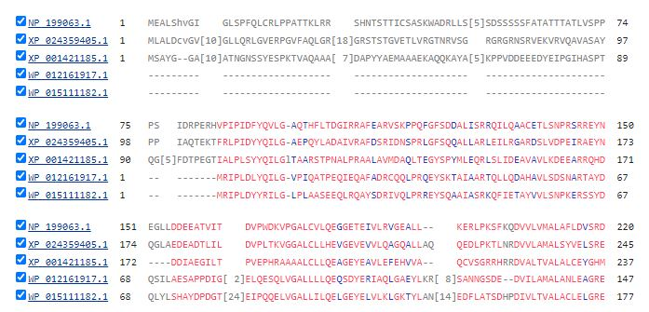etc.
Note where the homology starts for each protein in that alignment. Homologous regions (with identical or similar aminoacids at a given position) appear in red colour. You will note that for WP_012161917, the Acaryochloris marina homologue, the first conserved aminoacid, R (arginine) aligns with position 84, P (proline, another positively-charged aminoacid) for ARC6 in Arabidopsis. Remember the first aminocid is always M (methionine) for every protein in every organism, so its conservation is irrelevant. Obviously ARC6 is longer at this front (N-terminal) end in Arabidopsis, having an additional stretch of 83 aminoacids with no equivalent in the Acaryochloris counterpart. You may need this information for a later assessment.
Familiarise yourself with this process of searching and aligning, and obtaining a “graphical overview”, because you will have to carry out and display a similar one as part of the lab assessment. To display the outcome you will need to copy/print part of the image on the screen (in Windows, search and use “snipping tool”).

4. Examination of GUS activity in the different lines.

- Carefully remove, with the pipette, the GUS reaction buffer from each tube. Try to not damage the plants. Do this for both the seedlings you have incubated for at least 3 hours, and those identical ones you have been provided with, incubated for 24 hours.
- Place in each tube 1 ml of ethanol (to extract chlorophyll and reveal the blue pigment only).
- Place the tubes in the heat block at 65C, for about 5 min.

Ethanol is highly flammable

Beware of the hot temperature of the water bath

- Remove the ethanol |(containing extracted chlorophyll) from each tube, and repeat the last two steps with another ml of fresh ethanol. After the second extraction, replace it with water.
- Take the seedlings out of the tube and examine them macroscopically, or under the stereomicroscope as required. Comparison with an intact seedling will be helpful. Are the seedlings stained? Which areas are or are not? Observe the embryonic leaves (cotyledons), the embryonic stem (hypocotyl) and the root. Is there any correlation between the staining and the presence of chloroplasts (as indicated by green colour)? Draw a sketch (perhaps use an idealised seedling, and colour in where you find GUS product) as required.

Questions to consider:

For any form of assessment, consider the following:
- What is the impact of the arc6 mutation. What are the chloroplast numbers per cell? What is the phenotype of each chloroplast?
- From the alignment of ARC6-like proteins, there seem to be two groups of homologues, the full-length ones and the ones which are shorter at one end. Show this. Can you think of any explanation? (Hint: what determines the subcellular localisation of a protein?)
- Which cells/tissues expressed GUS in the pLchb::GUS line? How about in the p35S::GUS line? Show this. Why are they different? (Hint: did the expression correlate with the presence of green chloroplasts in those cells? In which case?)
- What effect did lincomycin exert on the expression of GUS in the pLchb::GUS and the p35S::GUS lines? Show this.
- In your words, what is the evidence in these two experiments that the chloroplasts depend on information contained in the nucleus, but are also themselves sending information to the nucleus?

References:
Pyke K (1999) Plastid division and development. Plant Cell 11, 549-556
Jarvis P and López-Juez E (2013) Biogenesis and homeostasis of chloroplasts and other plastids. Nature Reviews Molecular Cell Biology 14, 787-802.

